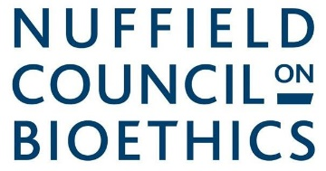
Realising the ethics commitments in the Genome UK strategy
Case study template
Use this template to tell us about how you went about tackling the ethical issues raised by a genomics initiative (more information is here). Please keep your case study to under 800 words and send to Catherine Joynson at bioethics@nuffieldbioethics.org by Monday 5 September 2022.

Name of initiative and people/organisation/s involved

Why did you think about ethics?
What outcome were you were hoping for?

What were the main ethical issues you encountered?
E.g. balancing benefits and harms, asking for consent, data privacy, respecting the interests of children and others who lack capacity, inequality, societal acceptability. How did you identify them?

How did you go about considering the ethical issues?
What inputs did you use e.g. multi-disciplinary expertise, academic literature, ethics and legal guidance, public and patient involvement, deliberation? Were you able to involve a range of voices and manage any vested interests?

What challenges did you encounter?
Were you able to overcome them? What could have helped?

What were the outcomes of thinking about ethics?
Did you reach consensus? What impact did your work have?

Any other relevant information about the initiative?

Thank you

